# 5. Appendix

## 5.1 – Source Code (Java)

### 5.1.1 *Calculator.java*

**package** com.calculatorproject;  
  
**import** android.content.Context;  
**import** android.content.Intent;  
**import** android.content.SharedPreferences;  
**import** android.content.pm.ActivityInfo;  
**import** android.os.Bundle;  
**import** android.os.Vibrator;  
**import** android.support.v7.app.AppCompatActivity;  
**import** android.support.v7.widget.Toolbar;  
**import** android.text.Html;  
**import** android.view.View;  
**import** android.widget.Button;  
**import** android.widget.TextView;  
**import** android.widget.Toast;  
  
**import** java.util.ArrayList;  
**import** java.util.Arrays;  
**import** java.util.EmptyStackException;  
  
**public class** Calculator **extends** AppCompatActivity {  
  
 **private** String **mInfix**;  
 **private** TextView **mCalculatorDisplay**;  
 **private** TextView **mOutputDisplay**;  
 **final** String **ops** = **"-+÷×^√"**;  
 **private int mPosition**;  
 **final** String **trigOps** = **"sctzef"**;  
 **private int counter**;  
 **private double roundValue**;  
 **private boolean hapticFeedback**;  
 **private** Vibrator **v**;  
  
 @Override  
 **public void** onCreate(Bundle savedInstanceState) {  
 **super**.onCreate(savedInstanceState);  
  
 setContentView(R.layout.***calc_main***);  
  
 *// Initialise toolbar* Toolbar toolbar = findViewById(R.id.***my_toolbar***);  
 setSupportActionBar(toolbar);  
  
 *// reset the display text sizes onCreate().* **mCalculatorDisplay** = findViewById(R.id.***calculatorDisplay***);  
 **mCalculatorDisplay**.setTextSize(getResources().getDimension(R.dimen.***regular***));  
 **mOutputDisplay** = findViewById(R.id.***outputDisplay***);  
 **mOutputDisplay**.setTextSize(getResources().getDimension(R.dimen.***regular***));  
  
 *// set HTML markup on buttons so the superscript and appears correctly.* Button xyPowerButton = findViewById(R.id.***xyPower***);  
 Button squarePowerButton = findViewById(R.id.***squarePower***);  
 Button xyRootButton = findViewById(R.id.***xyRoot***);  
  
 xyPowerButton.setText(Html.*fromHtml*(getString(R.string.***xyPower***)));  
 squarePowerButton.setText(Html.*fromHtml*(getString(R.string.***squarePower***)));  
 xyRootButton.setText(Html.*fromHtml*(getString(R.string.***xyRoot***)));  
  
 Button arcsinButton = findViewById(R.id.***sin_inverse***);  
 Button arccosButton = findViewById(R.id.***cos_inverse***);  
 Button arctanButton = findViewById(R.id.***tan_inverse***);  
  
 arcsinButton.setText(Html.*fromHtml*(getString(R.string.***sin_inverse***)));  
 arccosButton.setText(Html.*fromHtml*(getString(R.string.***cos_inverse***)));  
 arctanButton.setText(Html.*fromHtml*(getString(R.string.***tan_inverse***)));  
  
 *// reset the mInfix onCreate().* **mInfix** = **""**;  
 **counter** = 0;  
  
 *// gets SharedPreferences* SharedPreferences mPrefs = **this**.getSharedPreferences(**"calculator"**, Context.***MODE_PRIVATE***);  
  
 **if** (mPrefs.contains(**"decimalPoints"**)) {  
  
 *// gets user specified rounding value* **int** decimalPoints = mPrefs.getInt(**"decimalPoints"**, -1);  
  
 StringBuilder roundValueString = **new** StringBuilder(**"10"**);  
  
 *// creates string with zeroes corresponding to the user's value* **for** (**int** i = 0; i < decimalPoints; i++) {  
  
 roundValueString.append(**"0"**);  
 }  
  
 *// converts string to a double* **roundValue** = Double.*valueOf*(roundValueString.append(**".0"**).toString());  
  
 } **else** {  
  
 *// default rounding rounds to 10 decimal points* **roundValue** = 10000000000.0;  
 }  
  
  
 *// orientation is locked depending on user's choice. Defaults to portrait if no choice is  
 // made in Settings class (as true corresponds to portrait)* **if** (mPrefs.getBoolean(**"isPortrait"**, **true**)) {  
  
 setRequestedOrientation(ActivityInfo.***SCREEN_ORIENTATION_PORTRAIT***);  
 } **else** {  
  
 setRequestedOrientation(ActivityInfo.***SCREEN_ORIENTATION_LANDSCAPE***);  
 }  
  
 **v** = (Vibrator) **this**.getSystemService(Context.***VIBRATOR_SERVICE***);  
 **hapticFeedback** = mPrefs.getBoolean(**"feedbackIsChecked"**, **true**);  
 }  
  
 **public void** inputAC(View view) {  
  
 vibratePhone();  
  
 *// reset all displays and variables* **mInfix** = **""**;  
 **mPosition** = 0;  
 **mCalculatorDisplay**.setText(**""**);  
 **mOutputDisplay**.setText(**""**);  
 **counter** = 0;  
 }  
  
 **public void** inputDigit(View view) {  
  
 vibratePhone();  
  
 *// insert input into correct mPosition* String input = (String) view.getTag();  
  
 StringBuilder string = **new** StringBuilder(**mInfix**);  
 string.insert(**mPosition**, input);  
 **mInfix** = string.toString();  
  
 *// increment mPosition variable* **mPosition**++;  
  
 *// display to user* updateDisplay();  
 }  
  
 **public void** inputTrigonometry(View view) {  
  
 vibratePhone();  
  
 *// get operator from view's tag* String input = (String) view.getTag();  
  
 *// add buffer spaces to input* StringBuilder stringInput = **new** StringBuilder(input);  
 stringInput.  
 insert(stringInput.length(), **" "**)  
 .insert(0, **"0 "**);  
  
 input = stringInput.toString();  
  
  
 *// insert input into infix String* StringBuilder string = **new** StringBuilder(**mInfix**);  
 string.insert(**mPosition**, input);  
 **mInfix** = string.toString();  
  
 *// update position* **mPosition** = **mPosition** + 4;  
  
 *// update display* updateDisplay();  
 }  
  
 **public void** inputOperator(View view) {  
  
 vibratePhone();  
  
 *// get input operator from the view parameter's Tag (XML characteristic)* String input = (String) view.getTag();  
  
 *// add buffer spaces* StringBuilder stringInput = **new** StringBuilder(input);  
 stringInput.insert(0, **" "**)  
 .insert(stringInput.length(), **" "**);  
 input = stringInput.toString();  
  
 *// insert input into correct mPosition* StringBuilder string = **new** StringBuilder(**mInfix**);  
 string.insert(**mPosition**, input);  
 **mInfix** = string.toString();  
  
 *// adds +3 for the character and 2 whitespaces* **mPosition** = **mPosition** + 3;  
  
 *// display to user* updateDisplay();  
 }  
  
 **public void** inputOpShortcut(View view) {  
  
 vibratePhone();  
  
 StringBuilder stringBuilderInfix = **new** StringBuilder(**mInfix**);  
  
 *// if user taps square power button* **if** (view.getId() == R.id.***squarePower***) {  
  
 *// requires a whitespace at the start as it will always immediately follow a digit* stringBuilderInfix.insert(**mPosition**, **" ^ 2"**);  
  
 } **else** { *// if user taps square root button  
  
 // requires a trailing whitespace as a number or bracket will immediately follow* stringBuilderInfix.insert(**mPosition**, **"2 √ "**);  
 }  
  
 *// update position* **mPosition** = **mPosition** + 4;  
  
 *// set member infix variable to stringBuilder* **mInfix** = stringBuilderInfix.toString();  
  
 *// update GUI* updateDisplay();  
 }  
  
 **public void** inputBracket(View view) {  
  
 vibratePhone();  
  
 *// get input from the view's tag* String input = (String) view.getTag();  
  
 *// add buffer spaces to input* StringBuilder stringBuilderInput = **new** StringBuilder(input);  
 stringBuilderInput.insert(0, **" "**)  
 .append(**" "**);  
 input = stringBuilderInput.toString();  
  
 *// insert input into infix* StringBuilder stringBuilderInfix = **new** StringBuilder(**mInfix**);  
 stringBuilderInfix.insert(**mPosition**, input);  
 **mInfix** = stringBuilderInfix.toString();  
  
 *// update position* **mPosition** = **mPosition** + 3;  
  
 validateBracketMultiplication();  
 *// update GUI to show new infix* updateDisplay();  
  
 }  
  
 **public void** validateBracketMultiplication() {  
  
 vibratePhone();  
  
 StringBuilder stringBuilderInfix = **new** StringBuilder(**mInfix**);  
  
 *// validate length to prevent StringIndexOutOfBounds* **if** (**mInfix**.length() > 4) {  
  
 *// check if opening bracket* **if** (**mInfix**.charAt(**mPosition** - 2) == **'('** *// check if previous token is a digit* && Character.*isDigit*(**mInfix**.charAt(**mPosition** - 4))) {  
  
 *// insert multiplication token* stringBuilderInfix.insert(**mPosition** - 2, **"× "**);  
  
 *// update position variable* **mPosition** = **mPosition** + 2;  
 }  
 }  
  
 **mInfix** = stringBuilderInfix.toString();  
 }  
  
 **public void** delete(View view) {  
  
 vibratePhone();  
  
 StringBuilder stringBuilderInfix = **new** StringBuilder(**mInfix**);  
  
  
 *// validate string length to prevent crashes from StringIndexOutOfBounds* **if** (stringBuilderInfix.length() > 1) {  
  
 *// delete a single character by itself* **if** (Character.*isDigit*(stringBuilderInfix.charAt(**mPosition** - 1))  
 || **ops**.contains(String.*valueOf*(stringBuilderInfix.charAt(**mPosition** - 1)))  
 || stringBuilderInfix.charAt(**mPosition** - 1) == **'.'**) {  
  
 *// delete character* stringBuilderInfix.deleteCharAt(**mPosition** - 1);  
 **mPosition** --;  
  
 *// delete single character including whitespace (e.g. when there's an operator)* } **else if** (stringBuilderInfix.charAt(**mPosition** -1) == **' '**) {  
  
 *// remove token* stringBuilderInfix.deleteCharAt(**mPosition** - 1);  
  
 *// position must be updated before editing infix to prevent crashes* **mPosition** --;  
  
 *// remove whitespace* stringBuilderInfix.deleteCharAt(**mPosition** - 1);  
 **mPosition** --;  
 }  
  
  
 }  
  
 **mInfix** = stringBuilderInfix.toString();  
 updateDisplay();  
 }  
  
 **public void** submitInfix(View view) {  
  
 vibratePhone();  
  
 *// validation check to prevent StringIndexOutOfBounds* **if** (**mInfix**.length() > 0) {  
  
 *// try-catch to prevent crashes from badly formed input expressions* **try** {  
  
  
 *// get postfix* String mPostfix = ShuntingYard.*infixToPostfix*(removePositionMarker(**mInfix**));  
  
 *// get answer* **double** mAnswer = ShuntingYard.*evaluateRPN*(mPostfix);  
  
 mAnswer = Math.*round*(mAnswer * **roundValue**) / **roundValue**;  
 *// display answer to user* **mOutputDisplay**.setText(getString(R.string.***answer***, String.*valueOf*(mAnswer)));  
  
 } **catch** (EmptyStackException e) {  
 e.printStackTrace();  
  
 Toast.*makeText*(**this**, **"ERROR: expression is malformed"**,  
 Toast.***LENGTH_SHORT***).show();  
 }  
 }  
 }  
  
 **public void** shiftPosition(View view) {  
  
 vibratePhone();  
  
 *// user taps right button* **if** (view.getId() == R.id.***shiftRight***) {  
  
 *// validation to prevent StringIndexOutOfBoundsException* **if** (**mPosition** < **mInfix**.length() - 1) {  
  
 *// validation check to prevent StringIndexOutOfBoundsException* **if** (**mInfix**.length() - **mPosition** > 2) {  
  
 *// skips whitespace* **if** (**mInfix**.charAt(**mPosition** + 2) == **' '**) {  
  
 *// increments position variable by 2 to cover the whitespace* **mPosition** = **mPosition** + 2;  
  
 *// skips two whitespaces* } **else if**(**mInfix**.charAt(**mPosition** + 1) == **' '**) {  
  
 *// increment position by 3 when cursor is to the right of a digit to cover  
 // two whitespaces* **mPosition** = **mPosition** + 3;  
  
 } **else if** (Character.*isDigit*(**mInfix**.charAt(**mPosition** + 1))  
 || **trigOps**.contains(String.*valueOf*(**mInfix**.charAt(**mPosition** + 1)))) {  
  
 **mPosition** = **mPosition** + 1;  
 }  
  
 } **else** {  
  
 *// increments position variable* **mPosition**++;  
 }  
 }  
  
 } **else** { *// user shifts left  
  
 // validation check to prevent StringIndexOutOfBoundsException* **if** (**mPosition** > 0) {  
  
 *// skips whitespaces* **if** (**mInfix**.charAt(**mPosition** - 1) == **' '**) {  
  
 *// decreases position variable by 2 to cover the whitespace* **mPosition** = **mPosition** - 3;  
  
 } **else** {  
  
 *// decreases position variable* **mPosition**--;  
 }  
 }  
 }  
  
 *// update display* updateDisplay();  
  
 }  
  
 **public void** updateDisplay() {  
  
 *// remove the position marker* String cleanExpression = removePositionMarker(**mInfix**);  
  
 *// add underscore as a position marker to GUI* StringBuilder underscoreString = **new** StringBuilder(cleanExpression);  
 underscoreString.insert(**mPosition**, **"_"**);  
 **mInfix** = underscoreString.toString();  
  
 *// convert infix to array so it can be used in a for-each loop* ArrayList<String> infixList = **new** ArrayList<>(Arrays.*asList*(**mInfix**.split(**""**)));  
  
 *// create array of replacement strings* String[] trigArray = **new** String[]{**"sin"**, **"cos"**, **"tan"**, **"arcsin"**, **"arccos"**, **"arctan"**};  
  
 *// create new display StringBuilder* StringBuilder displayInfix = **new** StringBuilder();  
  
 *// iterate over each element in the infix* **for** (String character : infixList) {  
  
 *// if the current element is a trigonometric operator* **if** (**trigOps**.contains(character)) {  
  
 *// if counter is above 0 to prevent strange bug where there was always a "sin" at  
 // the start of the string* **if** (**counter** > 0) {  
  
 *// get index of character in the trigOps string* **int** trigIndex = **trigOps**.indexOf(character);  
  
 *// remove the place holder "0 "* displayInfix.deleteCharAt(displayInfix.length() -1 )  
 .deleteCharAt(displayInfix.length() - 1);  
 *// replace operator with string from the array* displayInfix.append(trigArray[trigIndex]);  
 }  
  
 *// iterate counter* **counter** ++;  
  
 } **else** {  
  
 *// add character to string as normal* displayInfix.append(character);  
 }  
 }  
  
 *// reset counter* **counter** = 0;  
  
 *// update display* **mCalculatorDisplay**.setText(displayInfix.toString());  
 }  
  
 **public void** vibratePhone() {  
 *// if haptic feedback is enabled, vibrate the phone for 500ms* **if**(**hapticFeedback**) {  
 **v**.vibrate(100);  
 }  
 }  
  
 **public** String removePositionMarker(String infix) {  
  
 *// replace underscore with empty string to remove it* **return** infix.replaceAll(**"_"**, **""**);  
 }  
  
 **public void** onClickEquations(View view) {  
  
 vibratePhone();  
  
 *// send to Equations activity* startActivity(**new** Intent(Calculator.**this**, Equations.**class**));  
 }  
  
 **public void** onClickConversions(View view) {  
  
 vibratePhone();  
  
 *// send to Conversion activity* startActivity(**new** Intent(Calculator.**this**, Conversions.**class**));  
 }  
  
 **public void** settings(View view) {  
  
 vibratePhone();  
  
 *// send to Settings activity* startActivity(**new** Intent(Calculator.**this**, Settings.**class**));  
 }  
}

### 5.1.2 *ShuntingYard.java*

**package** com.calculatorproject;  
  
**import** java.util.HashMap;  
**import** java.util.Map;  
**import** java.util.Stack;  
  
*/**  
 * This class handles everything relevant to the process of getting a value from the user's  
 * input expression.  
 *  
 * The user's input is converted to a postfix in Reverse Polish Notation using the infixToPostfix  
 * method. The postfix can then be used to calculate a result that is returned to the user.  
 *  
 \** ***@author*** *David Denny  
 * */***public class** ShuntingYard {  
*/**  
 * Method that takes the user's input and iterates through it to create a postfix in the form  
 * of Reverse Polish Notation and returns the postfix.  
 *  
 \** ***@param infix*** *user's input string  
 \** ***@return*** *postfix  
 * */* **static** String infixToPostfix(String infix) {  
  
 *// string that represents every operator. Each operator's precedence can be found by  
 // dividing the index of the operator by 2* **final** String mOps = **"-+÷×^√"**;  
  
 *// creates the postfix stringBuilder* StringBuilder mPostfix = **new** StringBuilder();  
  
 *// Create new stack containing integers* Stack<Integer> mStack = **new** Stack<>();  
  
 *// iteras through each token in the user's infix* **for** (String token : infix.split(**"\\s"**)) {  
 **if** (token.isEmpty()) {  
  
 *// if there isn't a token, it returns to the for-each loop* **continue**;  
 }  
  
 *// Char variable containing current token* **char** character = token.charAt(0);  
  
 *// index of where the token exists in the operator member variable* **int** index = mOps.indexOf(character);  
  
 *// if the token is an operator (i.e. exists in the mOps string)* **if** (index != -1) {  
  
 **if** (mStack.isEmpty()) {  
  
 *// push index of token onto the stack* mStack.push(index);  
  
 } **else** {  
  
 **while** (!mStack.isEmpty()) {  
  
 *// find precedence value of current and previous operators by dividing  
 // the index by two* **int** previousPrecedence = mStack.peek() / 2;  
 **int** currentPrecedence = index / 2;  
  
 *//if the previous operator is greater than the current operator or is the  
 // same as long as the current isn't a power* **if** (previousPrecedence > currentPrecedence ||  
 (previousPrecedence == currentPrecedence && character != **'^'**)) {  
  
 *// index of previous operator is popped off the stack and appends its  
 // corresponding character in the mOps string to the mPostfix string* mPostfix.append(mOps.charAt(mStack.pop())).append(**' '**);  
  
 } **else** {  
  
 *// break out of loop if prevPrecedence is not greater* **break**;  
 }  
 }  
  
 *// at the end of the stack, push the current token's index to the stack* mStack.push(index);  
 }  
  
 } **else if** (character == **'('**) {  
  
 *// push "-2" onto the stack to represent the starting bracket* mStack.push(-2);  
  
 } **else if** (character == **')'**) {  
  
 *// loops over the tokens inside the brackets* **while** (mStack.peek() != -2) {  
  
 *// appends all tokens inside the brackets to postfix stringBuilder to ensure  
 // that calculations inside the brackets are done first* mPostfix.append(mOps.charAt(mStack.pop())).append(**' '**);  
 }  
  
 *// pops the bracket off the stack* mStack.pop();  
  
 } **else** {  
  
 *// if the token is a digit (not bracket or operator), append it to the mPostfix  
 // stringBuilder* mPostfix.append(token).append(**' '**);  
 }  
 }  
  
 **while** (!mStack.isEmpty()) {  
  
 *// pops off and appends the remaining tokens to the mPostfix stringBuilder* mPostfix.append(mOps.charAt(mStack.pop())).append(**' '**);  
 }  
  
 *// returns the created postfix string which is now in Reverse Polish Notation* **return** mPostfix.toString();  
 }  
  
 */**  
 * Method to take the postfix string and convert it into a numerical result to be returned the  
 * user.  
 *  
 \** ***@param postfix*** *user's postfix that is used to calculate a result  
 \** ***@return*** *numerical value that is the result of the user's input expression  
 **/* **static** Double evaluateRPN(String postfix) {  
  
 *// make a stack containing Doubles* Stack<Double> tokens = **new** Stack<>();  
  
 *// for-each loop iterating over every token in the postfix (removing whitespaces to split  
 // each token up)* **for** (String token : postfix.split(**" "**)) {  
  
 *// finds the corresponding enum to the token* Sign sign = Sign.*find*(token);  
  
 *// if the .find() function succesfully finds a corresponding enum  
 // (i.e. the token is an operator)* **if** (sign != **null**) {  
  
 *// calls calcSign() function to apply the current operator to the first two  
 // doubles popped off the stack  
 calcSign*(tokens, sign);  
  
 } **else** { *// i.e. if the token is a number  
  
 // the token is casted to a Double to ensure data types are compatible* Double doubleToken = **new** Double(token);  
  
 *// push double onto the stack* tokens.push(doubleToken);  
  
 }  
 }  
  
 *// pops off the only number remaining in the stack after the loop. This will be the user's  
 // answer and returns it.* **return** tokens.pop();  
 }  
  
  
 **protected static** Stack<Double> calcSign(Stack<Double> tokens, Sign sign) {  
  
 *// pushes the result of the sign parameter with the first two tokens popped off the stack* tokens.push(sign.apply(tokens.pop(), tokens.pop()));  
  
 *// returns the stack where an operator has been used on two numbers* **return** tokens;  
 }  
  
 **public enum** Sign {  
  
 ***ADD***(**"+"**) {  
 **public** Double apply(Double num1, Double num2) {  
  
 *// adds the two input numbers* **return** num2 + num1;  
 }  
 },  
 ***SUBTRACT***(**"-"**) {  
 **public** Double apply(Double num1, Double num2) {  
  
 *// subtracts the first number from the second number* **return** num2 - num1;  
 }  
 },  
 ***MULTIPLY***(**"×"**) {  
 **public** Double apply(Double num1, Double num2) {  
  
 *// multiplies the input numbers* **return** num2 * num1;  
 }  
 },  
 ***DIVIDE***(**"÷"**) {  
 **public** Double apply(Double num1, Double num2) {  
  
 *// returns the second number divided by the first* **return** num2 / num1;  
 }  
 },  
 ***POWER***(**"^"**) {  
 **public** Double apply(Double num1, Double num2) {  
  
 *// returns the second number raised by the first* **return** Math.*pow*(num2, num1);  
 }  
 },  
 ***ROOT***(**"√"**) {  
 **public** Double apply(Double num1, Double num2) {  
  
 *// returns the second number rooted by the first* **return** Math.pow(num1, 1.0 / num2);  
 }  
 };  
  
 *// operator text constructor* **private final** String mOperatorText;  
  
 *// sets the corresponding string denoting the operator to the constructor* Sign(String operatorText) {  
 **this**.mOperatorText = operatorText;  
 }  
  
 *// abstract class to make the Sign's corresponding subclasses* **public abstract** Double apply(Double num1, Double num2);  
  
 *// create Map member variable made up of a string and enum* **private static final** Map<String, Sign> mMap;  
  
 **static** {  
  
 *// initialise mMap variable as a HashMap* mMap = **new** HashMap<>();  
  
 *// use a for-each loop to populate HashMap with the enum and it's corresponding string* **for** (Sign sign : Sign.values()) {  
 mMap.put(sign.mOperatorText, sign);  
 }  
 }  
  
  
 **public static** Sign find(String sign) {  
  
 *// returns the Sign enum if it exists in the HashMap* **return** mMap.get(sign);  
 }  
  
 }  
  
}

### 5.1.3 *Equations.java*

**package** com.calculatorproject;  
  
**import** android.content.Context;  
**import** android.content.Intent;  
**import** android.content.SharedPreferences;  
**import** android.content.pm.ActivityInfo;  
**import** android.os.Bundle;  
**import** android.support.v7.app.AppCompatActivity;  
**import** android.support.v7.widget.LinearLayoutManager;  
**import** android.support.v7.widget.RecyclerView;  
**import** android.support.v7.widget.Toolbar;  
**import** android.view.View;  
  
**public class** Equations **extends** AppCompatActivity {  
 Toolbar mToolbar;  
 RecyclerView mRecyclerView;  
  
 @Override  
 **protected void** onCreate(Bundle savedInstanceState) {  
 **super**.onCreate(savedInstanceState);  
 setContentView(R.layout.maths_equations);  
  
 *// initialise toolbar* mToolbar = findViewById(R.id.quadratic_equation_toolbar);  
 setSupportActionBar(mToolbar);  
  
 *// initialise RecyclerView* mRecyclerView = findViewById(R.id.maths_equation_recycler);  
 EquationsRAdapter adapter = **new** EquationsRAdapter(**this**);  
  
 mRecyclerView.setAdapter(adapter);  
 mRecyclerView.setLayoutManager(**new** LinearLayoutManager(**this**));  
  
 *// gets SharedPreferences* SharedPreferences mPrefs = **this**.getSharedPreferences(**"calculator"**, Context.MODE_PRIVATE);  
  
 *// orientation is locked depending on user's choice. Defaults to portrait if no choice is  
 // made in Settings class (as true corresponds to portrait)* **if** (mPrefs.getBoolean(**"isPortrait"**, **true**)) {  
  
 setRequestedOrientation(ActivityInfo.SCREEN_ORIENTATION_PORTRAIT);  
 } **else** {  
  
 setRequestedOrientation(ActivityInfo.SCREEN_ORIENTATION_LANDSCAPE);  
 }  
 }  
  
 **public void** handleBackButton(View view) {  
  
 startActivity(**new** Intent(Equations.**this**, Calculator.**class**));  
 }  
}

### 5.1.4 *EquationsRAdapter.java*

**package** com.calculatorproject;  
  
**import** android.content.Context;  
**import** android.content.Intent;  
**import** android.support.annotation.NonNull;  
**import** android.support.v7.widget.RecyclerView;  
**import** android.view.LayoutInflater;  
**import** android.view.View;  
**import** android.view.ViewGroup;  
**import** android.widget.RelativeLayout;  
**import** android.widget.TextView;  
  
**import** java.util.ArrayList;  
  
**public class** EquationsRAdapter **extends** RecyclerView.Adapter<EquationsRAdapter.ViewHolder> {  
  
 **private** ArrayList<String> **mContentArray**;  
 **private** RecyclerView **mRecyclerView**;  
 **private** View.OnClickListener **mOnClickListener** = **new** View.OnClickListener() {  
 @Override  
 **public void** onClick(View v) {  
  
 *// get position for switch-case statement* **int** position = **mRecyclerView**.getChildLayoutPosition(v);  
  
 **switch**(position) {  
  
 *//Quadratic Equation* **case** 0:  
 v.getContext().startActivity(  
 **new** Intent(v.getContext(), QuadraticEquation.**class**));  
 **break**;  
  
 *// Pythagoras' Theorem* **case** 1:  
  
 v.getContext().startActivity(  
 **new** Intent(v.getContext(), PythagorasTheorem.**class**));  
 **break**;  
  
 *// Cosine Rule* **case** 2:  
  
 v.getContext().startActivity(**new** Intent(v.getContext(), CosineRule.**class**));  
 **break**;  
  
 *// Sine Rule* **case** 3:  
 v.getContext().startActivity(**new** Intent(v.getContext(), SineRule.**class**));  
 **break**;  
  
 *// Area of a Triangle* **case** 4:  
 v.getContext().startActivity(**new** Intent(v.getContext(), AreaTriangle.**class**));  
 **break**;  
 }  
  
 }  
 };  
  
 **public static class** ViewHolder **extends** RecyclerView.ViewHolder {  
  
 **public** RelativeLayout **mRow**;  
 **public** TextView **mContent**;  
  
 **public** ViewHolder(View itemView) {  
 **super**(itemView);  
  
 *// set member variables* **mRow** = itemView.findViewById(R.id.***default_recycler_row***);  
 **mContent** = itemView.findViewById(R.id.***default_recycler_content***);  
 }  
 }  
  
 **public** EquationsRAdapter(Context context) {  
  
 **mContentArray** = **new** ArrayList<>();  
  
 *// add content to array to be later used to populate the RecyclerView* **mContentArray**.add(**"Quadratic Equation"**);  
 **mContentArray**.add(**"Pythagoras' Theorem"**);  
 **mContentArray**.add(**"Cosine Rule"**);  
 **mContentArray**.add(**"Sine Rule"**);  
 **mContentArray**.add(**"Area of a Triangle"**);  
 }  
  
 @NonNull  
 @Override  
 **public** EquationsRAdapter.ViewHolder onCreateViewHolder(@NonNull ViewGroup parent, **int** viewType) {  
  
 *// inflates each row of the RecyclerView* LayoutInflater inflater = LayoutInflater.*from*(parent.getContext());  
 View view = inflater.inflate(R.layout.***recycler_default_row***, parent, **false**);  
  
 *// sets the onClickListener on each row* view.setOnClickListener(**mOnClickListener**);  
 **return new** ViewHolder(view);  
 }  
  
 @Override  
 **public void** onBindViewHolder(@NonNull EquationsRAdapter.ViewHolder holder, **int** position) {  
  
 *// set text for each element of the RecyclerView* TextView contentTextView = holder.**mContent**;  
 contentTextView.setText(**mContentArray**.get(position));  
 }  
  
 @Override  
 **public int** getItemCount() {  
  
 *// returns size of RecyclerView* **return mContentArray**.size();  
 }  
  
 @Override  
 **public void** onAttachedToRecyclerView(@NonNull RecyclerView recyclerView) {  
 **super**.onAttachedToRecyclerView(recyclerView);  
  
 *// set member variable to RecyclerView so it can be used to find the position* **mRecyclerView** = recyclerView;  
 }  
}

### 5.1.5 *QuadraticEquation.java*

**package** com.calculatorproject;  
  
**import** android.content.Context;  
**import** android.content.Intent;  
**import** android.content.SharedPreferences;  
**import** android.content.pm.ActivityInfo;  
**import** android.os.Bundle;  
**import** android.support.v7.app.AppCompatActivity;  
**import** android.text.Editable;  
**import** android.text.Html;  
**import** android.text.TextWatcher;  
**import** android.view.View;  
**import** android.view.inputmethod.InputMethodManager;  
**import** android.widget.EditText;  
**import** android.widget.TextView;  
**import** android.widget.Toast;  
  
**import** io.github.kexanie.library.MathView;  
  
**public class** QuadraticEquation **extends** AppCompatActivity {  
 MathView **quadraticDisplay**;  
 String **aString**;  
 String **bString**;  
 String **cString**;  
  
 @Override  
 **protected void** onCreate(Bundle savedInstanceState) {  
 **super**.onCreate(savedInstanceState);  
 setContentView(R.layout.***quadratic_equation***);  
  
 *// set default quadratic equation* **aString** = **"a"**;  
 **bString** = **"b"**;  
 **cString** = **"c"**;  
  
 *// initialise display TextView* **quadraticDisplay** = findViewById(R.id.***quadratic_display***);  
  
 *// Use string substitution to get text to be displayed and set it to the textview* updateDisplay();  
  
 *// get EditText* EditText aInput = findViewById(R.id.***a_input***);  
 EditText bInput = findViewById(R.id.***b_input***);  
 EditText cInput = findViewById(R.id.***c_input***);  
  
 *// Set TextWatcher to update display when user inputs into "a" EditText* TextWatcher aTextWatcher = **new** TextWatcher() {  
 @Override  
 **public void** beforeTextChanged(CharSequence s, **int** start, **int** count, **int** after) {  
  
 }  
  
 @Override  
 **public void** onTextChanged(CharSequence s, **int** start, **int** before, **int** count) {  
  
 }  
  
 @Override  
 **public void** afterTextChanged(Editable s) {  
 **aString** = s.toString();  
 updateDisplay();  
  
 }  
 };  
  
 *// Set TextWatcher to update display when user inputs into "b" EditText* TextWatcher bTextWatcher = **new** TextWatcher() {  
 @Override  
 **public void** beforeTextChanged(CharSequence s, **int** start, **int** count, **int** after) {  
  
 }  
  
 @Override  
 **public void** onTextChanged(CharSequence s, **int** start, **int** before, **int** count) {  
  
 }  
  
 @Override  
 **public void** afterTextChanged(Editable s) {  
 **bString** = s.toString();  
 updateDisplay();  
 }  
 };  
  
 *// Set TextWatcher to update display when user inputs into "c" EditText* TextWatcher cTextWatcher = **new** TextWatcher() {  
 @Override  
 **public void** beforeTextChanged(CharSequence s, **int** start, **int** count, **int** after) {  
  
 }  
  
 @Override  
 **public void** onTextChanged(CharSequence s, **int** start, **int** before, **int** count) {  
  
 }  
  
 @Override  
 **public void** afterTextChanged(Editable s) {  
 **cString** = s.toString();  
 updateDisplay();  
 }  
 };  
  
 *// add TextWatchers to the EditTexts* aInput.addTextChangedListener(aTextWatcher);  
 bInput.addTextChangedListener(bTextWatcher);  
 cInput.addTextChangedListener(cTextWatcher);  
  
 *// gets SharedPreferences* SharedPreferences mPrefs = **this**.getSharedPreferences(**"calculator"**, Context.***MODE_PRIVATE***);  
  
 *// orientation is locked depending on user's choice. Defaults to portrait if no choice is  
 // made in Settings class (as true corresponds to portrait)* **if** (mPrefs.getBoolean(**"isPortrait"**, **true**)) {  
  
 setRequestedOrientation(ActivityInfo.***SCREEN_ORIENTATION_PORTRAIT***);  
 } **else** {  
  
 setRequestedOrientation(ActivityInfo.***SCREEN_ORIENTATION_LANDSCAPE***);  
 }  
 }  
  
 **public void** calculateQuadratic(View view) {  
  
  
 *// hide keyboard on button click* InputMethodManager inputManager = (InputMethodManager)  
 getSystemService(Context.***INPUT_METHOD_SERVICE***);  
 **assert** inputManager != **null**;  
 inputManager.hideSoftInputFromWindow(getCurrentFocus().getWindowToken(),  
 InputMethodManager.***HIDE_NOT_ALWAYS***);  
  
 *// initialise output TextViews* TextView textOutput = findViewById(R.id.***quadratic_output_text***);  
 TextView rootOutput = findViewById(R.id.***quadratic_output_roots***);  
 TextView discriminantOutput = findViewById(R.id.***quadratic_output_discriminant***);  
  
 *// validation to prevent crashes from NumberFormatException caused by the user not  
 // inputting all the required values* **try** {  
  
 *// initialise variable values* **double** a = Double.*parseDouble*(**aString**);  
 **double** b = Double.*parseDouble*(**bString**);  
 **double** c = Double.*parseDouble*(**cString**);  
  
 *// calculate the discriminant* **double** discriminant = b * b - 4 * a * c;  
  
 *// two real roots* **if** (discriminant > 0) {  
  
 *// calculate roots* **double** firstRoot = (-b + Math.*sqrt*(discriminant)) / (2 * a);  
 **double** secondRoot = (-b - Math.*sqrt*(discriminant)) / (2 * a);  
  
 *// display roots* textOutput.setText(R.string.***quadraticTextMultipleRoots***);  
 rootOutput.setText(Html.*fromHtml*(getString(R.string.***quadraticOutputMultipleRoots***,  
 String.*valueOf*(firstRoot), String.*valueOf*(secondRoot)))  
 );  
  
 *// repeated real roots* } **else if** (discriminant == 0) {  
  
 *// calculate root* **double** root = (-b + Math.*sqrt*(discriminant)) / (2 * a);  
  
 *// display root* textOutput.setText(R.string.***quadraticRepeatedRootsText***);  
 rootOutput.setText(getString(R.string.***quadraticOutputRepeatedRoots***, String.*valueOf*(root)));  
  
 *// no real roots* } **else** {  
 *// display lack of roots to the user.* textOutput.setText(R.string.***quadraticOutputNoRealRoots***);  
 }  
  
 *// display the discriminant* discriminantOutput.setText(  
 getString(R.string.***quadraticOutputDiscriminant***, String.*valueOf*(discriminant)));  
 } **catch** (NumberFormatException e) {  
   
 *// inform user of error* Toast.*makeText*(**this**, **"ERROR: input all required values"**, Toast.***LENGTH_SHORT***).show();  
 }  
 }  
  
 **public void** updateDisplay() {  
  
 *// create TeX code* String quadraticEquation = String.*format*(  
 **"$$\\color{white}{x = \\frac{- %2$s \\pm \\sqrt{%2$s^2 - 4 \\times %1$s \\times %3$s}}{2 \\times %1$s}}$$"**,  
 **aString**, **bString**, **cString**);  
  
 *// render and display TeX code* **quadraticDisplay**.setText(quadraticEquation);  
  
 }  
  
 *// send user to Equations class onclick* **public void** handleBackButton(View view) {  
 startActivity(**new** Intent(QuadraticEquation.**this**, Equations.**class**));  
 }  
  
}

### 5.1.6 *PythagorasThereom.java*

**package** com.calculatorproject;  
  
**import** android.content.Context;  
**import** android.content.Intent;  
**import** android.content.SharedPreferences;  
**import** android.content.pm.ActivityInfo;  
**import** android.os.Bundle;  
**import** android.support.v7.app.AppCompatActivity;  
**import** android.text.Editable;  
**import** android.text.TextWatcher;  
**import** android.view.View;  
**import** android.view.inputmethod.InputMethodManager;  
**import** android.widget.EditText;  
**import** android.widget.TextView;  
**import** android.widget.Toast;  
  
**import** io.github.kexanie.library.MathView;  
  
**public class** PythagorasTheorem **extends** AppCompatActivity {  
  
 MathView pythagorasDisplay;  
 String aString;  
 String bString;  
 String cString;  
 EditText aInput;  
 EditText bInput;  
 EditText cInput;  
 TextView pythagorasTextOutput;  
 TextView pythagorasAnswerOutput;  
  
 @Override  
 **protected void** onCreate(Bundle savedInstanceState) {  
 **super**.onCreate(savedInstanceState);  
 setContentView(R.layout.pythagoras_theorem);  
  
 *// set default quadratic equation* aString = **"a"**;  
 bString = **"b"**;  
 cString = **"c"**;  
  
 *// initialise display TextView* pythagorasDisplay = findViewById(R.id.pythagoras_display);  
  
 *// find and set display text* updateDisplay();  
  
 *// initialise output TextViews* pythagorasTextOutput = findViewById(R.id.pythagoras_output_text);  
 pythagorasAnswerOutput = findViewById(R.id.pythagoras_output_answer);  
  
 *// initialise input EditTexts* aInput = findViewById(R.id.pythagorasAInput);  
 bInput = findViewById(R.id.pythagorasBInput);  
 cInput = findViewById(R.id.pythagorasCInput);  
  
 *// set TextWatcher to update display after user input* TextWatcher aTextWatcher = **new** TextWatcher() {  
 @Override  
 **public void** beforeTextChanged(CharSequence s, **int** start, **int** count, **int** after) {  
  
 }  
  
 @Override  
 **public void** onTextChanged(CharSequence s, **int** start, **int** before, **int** count) {  
  
 }  
  
 @Override  
 **public void** afterTextChanged(Editable s) {  
 *// get input* aString = s.toString();  
  
 *// display new input to user* updateDisplay();  
  
 }  
 };  
  
 TextWatcher bTextWatcher = **new** TextWatcher() {  
 @Override  
 **public void** beforeTextChanged(CharSequence s, **int** start, **int** count, **int** after) {  
  
 }  
  
 @Override  
 **public void** onTextChanged(CharSequence s, **int** start, **int** before, **int** count) {  
  
 }  
  
 @Override  
 **public void** afterTextChanged(Editable s) {  
 *// get input* bString = s.toString();  
  
 *// apply new input* updateDisplay();  
  
 }  
 };  
  
 TextWatcher cTextWatcher = **new** TextWatcher() {  
 @Override  
 **public void** beforeTextChanged(CharSequence s, **int** start, **int** count, **int** after) {  
  
 }  
  
 @Override  
 **public void** onTextChanged(CharSequence s, **int** start, **int** before, **int** count) {  
  
 }  
  
 @Override  
 **public void** afterTextChanged(Editable s) {  
 *//get input* **cString** = s.toString();  
  
 *// apply input* updateDisplay();  
  
 }  
 };  
  
 *// add listeners to each EditText* **aInput**.addTextChangedListener(aTextWatcher);  
 **bInput**.addTextChangedListener(bTextWatcher);  
 **cInput**.addTextChangedListener(cTextWatcher);  
  
 *// gets SharedPreferences* SharedPreferences mPrefs = **this**.getSharedPreferences(**"calculator"**, Context.***MODE_PRIVATE***);  
  
 *// orientation is locked depending on user's choice. Defaults to portrait if no choice is  
 // made in Settings class (as true corresponds to portrait)* **if** (mPrefs.getBoolean(**"isPortrait"**, **true**)) {  
  
 setRequestedOrientation(ActivityInfo.***SCREEN_ORIENTATION_PORTRAIT***);  
 } **else** {  
  
 setRequestedOrientation(ActivityInfo.***SCREEN_ORIENTATION_LANDSCAPE***);  
 }  
 }  
  
 **public void** calculatePythagoras(View view) {  
  
 *// hide keyboard on button click* InputMethodManager inputManager = (InputMethodManager)  
 getSystemService(Context.***INPUT_METHOD_SERVICE***);  
 **assert** inputManager != **null**;  
 inputManager.hideSoftInputFromWindow(getCurrentFocus().getWindowToken(),  
 InputMethodManager.***HIDE_NOT_ALWAYS***);  
  
 *// prevents crashes from NumberFormatException when the user hasn't input the required  
 // values* **try** {  
  
 *// "c" is left empty, so calculate hypotenuse* **if** (**cInput**.getText().toString().equals(**""**)) {  
  
 *// get values of triangle sides* **double** a = Double.*parseDouble*(**aString**);  
 **double** b = Double.*parseDouble*(**bString**);  
  
 *// calculate the hypotenuse* **double** c = Math.*sqrt*((a * a) + (b * b));  
  
 *// display answer* pythagorasTextOutput.setText(R.string.pythagoras_text_hypotenuse);  
 pythagorasAnswerOutput.setText(String.valueOf(c));  
  
 *// "a" XOR "b" is empty so calculate the side. Exclusive Or is used here to make sure  
 // at least one side is inputted* } **else if** (aInput.getText().toString().equals(**""**) ^ bInput.getText().toString().equals(**""**)) {  
  
 *// calculate a* **if** (aInput.getText().toString().equals(**""**)) {  
  
 *// get side and hypotenuse values* **double** b = Double.parseDouble(bString);  
 **double** c = Double.parseDouble(cString);  
  
 *// only continue if hypotenuse is greater than the side* **if** (c > b) {  
  
 *// calculate side a* **double** a = Math.sqrt((c * c) - (b * b));  
  
 *// display answer* pythagorasTextOutput.setText(R.string.pythagoras_text_a);  
 pythagorasAnswerOutput.setText(String.valueOf(a));  
 } **else** {  
  
 Toast.makeText(**this**,  
 **"ERROR: a side cannot be larger than the hypotenuse."**,  
 Toast.LENGTH_SHORT).show();  
 }  
  
 *// calculate b* } **else** {  
  
 *// get side and hypotenuse values* **double** a = Double.parseDouble(aString);  
 **double** c = Double.parseDouble(cString);  
  
 *// only continue if hypotenuse is greater than the side* **if** (c > a) {  
  
 *// calculate side b* **double** b = Math.sqrt((c * c) - (a * a));  
  
 *// display answer* pythagorasTextOutput.setText(R.string.pythagoras_text_b);  
 pythagorasAnswerOutput.setText(String.valueOf(b));  
 } **else** {  
  
 Toast.makeText(**this**,  
 **"ERROR: a side cannot be larger than the hypotenuse."**,  
 Toast.LENGTH_SHORT).show();  
 }  
 }  
 } **else** {  
 Toast.makeText(**this**,  
  
 **"ERROR: make sure you leave one variable blank"**, Toast.LENGTH_SHORT).show();  
 }  
  
 } **catch** (NumberFormatException e) {  
  
 *// inform user of error* Toast.makeText(**this**,  
 **"ERROR: input all required values"**, Toast.LENGTH_SHORT).show();  
 }  
 }  
  
 *// update user's input in display expression* **public void** updateDisplay() {  
  
 *// create Spanned containing new input* String pythagorasExpression = String.format(  
 **"$$\\color{white}{%1$s^2 + %2$s^2 = %3$s^2}$$"**,  
 aString, bString, cString);  
  
 *// display new input* pythagorasDisplay.setText(pythagorasExpression);  
 }  
  
 *// send user back to MathsEquation* **public void** handleBackButton(View view) {  
  
 startActivity(**new** Intent(PythagorasTheorem.**this**, Equations.**class**));  
 }  
}

### 5.1.7 *CosineRule.java*

**package** com.calculatorproject;  
  
**import** android.content.Context;  
**import** android.content.Intent;  
**import** android.content.SharedPreferences;  
**import** android.content.pm.ActivityInfo;  
**import** android.os.Bundle;  
**import** android.support.v7.app.AppCompatActivity;  
**import** android.text.Editable;  
**import** android.text.TextWatcher;  
**import** android.view.View;  
**import** android.view.inputmethod.InputMethodManager;  
**import** android.widget.EditText;  
**import** android.widget.TextView;  
**import** android.widget.Toast;  
  
**import** io.github.kexanie.library.MathView;  
  
**public class** CosineRule **extends** AppCompatActivity {  
  
 MathView **cosineDisplay**;  
 String **aString**;  
 String **bString**;  
 String **cString**;  
 String **angleString**;  
 EditText **aInput**;  
 EditText **bInput**;  
 EditText **cInput**;  
 EditText **angleInput**;  
 TextView **cosineTextOutput**;  
 TextView **cosineAnswerOutput**;  
  
 @Override  
 **protected void** onCreate(Bundle savedInstanceState) {  
 **super**.onCreate(savedInstanceState);  
 setContentView(R.layout.***cosine_rule***);  
  
 *// set generic cosine equation values* **aString** = **"a"**;  
 **bString** = **"b"**;  
 **cString** = **"c"**;  
 **angleString** = **"A"**;  
  
 *// initialise display MathView* **cosineDisplay** = findViewById(R.id.***cosine_display***);  
  
 *// find and set display text* setDisplayExpression();  
  
 *// initialise output TextViews* **cosineTextOutput** = findViewById(R.id.***cosine_output_text***);  
 **cosineAnswerOutput** = findViewById(R.id.***cosine_output_answer***);  
  
 *// initialise input EditTexts* **aInput** = findViewById(R.id.***cosine_a_input***);  
 **bInput** = findViewById(R.id.***cosine_b_input***);  
 **cInput** = findViewById(R.id.***cosine_c_input***);  
 **angleInput** = findViewById(R.id.***cosine_angle_input***);  
  
 *// set TextWatchers to update display after user input* TextWatcher aTextWatcher = **new** TextWatcher() {  
 @Override  
 **public void** beforeTextChanged(CharSequence s, **int** start, **int** count, **int** after) {}  
  
 @Override  
 **public void** onTextChanged(CharSequence s, **int** start, **int** before, **int** count) {}  
  
 @Override  
 **public void** afterTextChanged(Editable s) {  
 *// get input* **aString** = s.toString();  
  
 *// display new input to user* setDisplayExpression();  
 }  
 };  
  
 TextWatcher bTextWatcher = **new** TextWatcher() {  
 @Override  
 **public void** beforeTextChanged(CharSequence s, **int** start, **int** count, **int** after) {}  
  
 @Override  
 **public void** onTextChanged(CharSequence s, **int** start, **int** before, **int** count) {}  
  
 @Override  
 **public void** afterTextChanged(Editable s) {  
 *// get input* **bString** = s.toString();  
  
 *// display new input to user* setDisplayExpression();  
 }  
 };  
  
 TextWatcher cTextWatcher = **new** TextWatcher() {  
 @Override  
 **public void** beforeTextChanged(CharSequence s, **int** start, **int** count, **int** after) {}  
  
 @Override  
 **public void** onTextChanged(CharSequence s, **int** start, **int** before, **int** count) {}  
  
 @Override  
 **public void** afterTextChanged(Editable s) {  
 *// get input* **cString** = s.toString();  
  
 *// display new input to user* setDisplayExpression();  
 }  
 };  
  
 TextWatcher angleTextWatcher = **new** TextWatcher() {  
 @Override  
 **public void** beforeTextChanged(CharSequence s, **int** start, **int** count, **int** after) {}  
  
 @Override  
 **public void** onTextChanged(CharSequence s, **int** start, **int** before, **int** count) {}  
  
 @Override  
 **public void** afterTextChanged(Editable s) {  
 *// get input* **angleString** = s.toString();  
  
 *// display new input to user* setDisplayExpression();  
 }  
 };  
  
 **aInput**.addTextChangedListener(aTextWatcher);  
 **bInput**.addTextChangedListener(bTextWatcher);  
 **cInput**.addTextChangedListener(cTextWatcher);  
 **angleInput**.addTextChangedListener(angleTextWatcher);  
  
 *// gets SharedPreferences* SharedPreferences mPrefs = **this**.getSharedPreferences(**"calculator"**, Context.***MODE_PRIVATE***);  
  
 *// orientation is locked depending on user's choice. Defaults to portrait if no choice is  
 // made in Settings class (as true corresponds to portrait)* **if** (mPrefs.getBoolean(**"isPortrait"**, **true**)) {  
  
 setRequestedOrientation(ActivityInfo.***SCREEN_ORIENTATION_PORTRAIT***);  
 } **else** {  
  
 setRequestedOrientation(ActivityInfo.***SCREEN_ORIENTATION_LANDSCAPE***);  
 }  
 }  
  
 **public void** setDisplayExpression() {  
  
 *// get the String to be used with string substitution string substitution* String cosineRule = String.*format*(  
 **"$$\\color{white}{%1$s^2 = %2$s^2 + %3$s^2 \\times %2$s \\times %3$s \\times cos(%4$s)}$$"**,  
 **aString**, **bString**, **cString**, **angleString**);  
  
  
 *// set TextView to user's new expression* **cosineDisplay**.setText(cosineRule);  
 }  
  
 **public void** calculateCosineRule(View view) {  
  
 *// hide keyboard on button click* InputMethodManager inputManager = (InputMethodManager)  
 getSystemService(Context.***INPUT_METHOD_SERVICE***);  
 **assert** inputManager != **null**;  
 inputManager.hideSoftInputFromWindow(getCurrentFocus().getWindowToken(),  
 InputMethodManager.***HIDE_NOT_ALWAYS***);  
   
 **try** {  
  
  
 *// user wants to calculate "a"* **if** (**aInput**.getText().toString().equals(**""**)) {  
  
 *// get sides and angle values* **double** b = Double.*parseDouble*(**bString**);  
 **double** c = Double.*parseDouble*(**cString**);  
 **double** angle = Double.*parseDouble*(**angleString**);  
  
 *// convert angle to radians as Math.cos() interprets the input as radians* angle = Math.*toRadians*(angle);  
  
 *// calculate the side a* **double** a = Math.*sqrt*((b * b) + (c * c) * 2.0 * b * c * Math.*cos*(angle));  
  
 *// display answer to user* **cosineTextOutput**.setText(R.string.***cosine_text_side***);  
 **cosineAnswerOutput**.setText(String.*valueOf*(a));  
  
 *// user wants to calculate the angle* } **else if** (**angleInput**.getText().toString().equals(**""**)) {  
  
 **double** a = Double.*parseDouble*(**aString**);  
 **double** b = Double.*parseDouble*(**bString**);  
 **double** c = Double.*parseDouble*(**cString**);  
  
 **double** angle = Math.*toDegrees*(Math.*acos*(((a * a) - (b * b) - (c * c)) / (2 * b * c)));  
  
 **cosineTextOutput**.setText(R.string.***cosine_text_angle***);  
 **cosineAnswerOutput**.setText(getString(R.string.***cosine_answer_angle***, String.*valueOf*(angle)));  
  
 *// user has made an error inputting their values* } **else** {  
 Toast.*makeText*(**this**,  
 **"ERROR: your inputs are not valid"**, Toast.***LENGTH_SHORT***).show();  
 }  
 } **catch** (NumberFormatException e) {  
  
 Toast.*makeText*(**this**,  
 **"ERROR: input all required values"**, Toast.***LENGTH_SHORT***).show();  
 }  
 }  
  
 **public void** handleBackButton(View view) {  
  
 startActivity(**new** Intent(CosineRule.**this**, Equations.**class**));  
 }  
}

### 5.1.8 *SineRule.java*

**package** com.calculatorproject;  
  
**import** android.content.Context;  
**import** android.content.Intent;  
**import** android.content.SharedPreferences;  
**import** android.content.pm.ActivityInfo;  
**import** android.os.Bundle;  
**import** android.support.v7.app.AppCompatActivity;  
**import** android.text.Editable;  
**import** android.text.TextWatcher;  
**import** android.view.View;  
**import** android.view.inputmethod.InputMethodManager;  
**import** android.widget.EditText;  
**import** android.widget.TextView;  
**import** android.widget.Toast;  
  
**import** io.github.kexanie.library.MathView;  
  
  
**public class** SineRule **extends** AppCompatActivity {  
 MathView **sineDisplay**;  
 String **aString**;  
 String **bString**;  
 String **aAngleString**;  
 String **bAngleString**;  
 EditText **aInput**;  
 EditText **aAngleInput**;  
 EditText **bInput**;  
 EditText **bAngleInput**;  
 TextView **sineTextOutput**;  
 TextView **sineAnswerOutput**;  
  
 @Override  
 **protected void** onCreate(Bundle savedInstanceState) {  
 **super**.onCreate(savedInstanceState);  
 setContentView(R.layout.***sine_rule***);  
  
 *// initialise variables* **aString** = **"a"**;  
 **bString** = **"b"**;  
 **aAngleString** = **"A"**;  
 **bAngleString** = **"B"**;  
  
 *// get MathView display* **sineDisplay** = findViewById(R.id.***sine_display***);  
  
 *// update display* updateDisplay();  
  
 *// initialise EditTexts* **aInput** = findViewById(R.id.***a_sine_input***);  
 **aAngleInput** = findViewById(R.id.***a_capital_sine_input***);  
 **bInput** = findViewById(R.id.***b_sine_input***);  
 **bAngleInput** = findViewById(R.id.***b_capital_sine_input***);  
  
 *// initialise output TextViews* **sineTextOutput** = findViewById(R.id.***sine_output_text***);  
 **sineAnswerOutput** = findViewById(R.id.***sine_output_answer***);  
  
 *// set TextWatchers to update display after user input* TextWatcher aTextWatcher = **new** TextWatcher() {  
 @Override  
 **public void** beforeTextChanged(CharSequence s, **int** start, **int** count, **int** after) {}  
  
 @Override  
 **public void** onTextChanged(CharSequence s, **int** start, **int** before, **int** count) {}  
  
 @Override  
 **public void** afterTextChanged(Editable s) {  
 *// get input* **aString** = s.toString();  
  
 *// display new input to user* updateDisplay();  
 }  
 };  
  
 TextWatcher aCapitalTextWatcher = **new** TextWatcher() {  
 @Override  
 **public void** beforeTextChanged(CharSequence s, **int** start, **int** count, **int** after) {}  
  
 @Override  
 **public void** onTextChanged(CharSequence s, **int** start, **int** before, **int** count) {}  
  
 @Override  
 **public void** afterTextChanged(Editable s) {  
 *// get input* **aAngleString** = s.toString();  
  
 *// display new input to user* updateDisplay();  
 }  
 };  
  
 TextWatcher bTextWatcher = **new** TextWatcher() {  
 @Override  
 **public void** beforeTextChanged(CharSequence s, **int** start, **int** count, **int** after) {}  
  
 @Override  
 **public void** onTextChanged(CharSequence s, **int** start, **int** before, **int** count) {}  
  
 @Override  
 **public void** afterTextChanged(Editable s) {  
 *// get input* **bString** = s.toString();  
  
 *// display new input to user* updateDisplay();  
 }  
 };  
  
 TextWatcher bCapitalTextWatcher = **new** TextWatcher() {  
 @Override  
 **public void** beforeTextChanged(CharSequence s, **int** start, **int** count, **int** after) {}  
  
 @Override  
 **public void** onTextChanged(CharSequence s, **int** start, **int** before, **int** count) {}  
  
 @Override  
 **public void** afterTextChanged(Editable s) {  
 *// get input* **bAngleString** = s.toString();  
  
 *// display new input to user* updateDisplay();  
 }  
 };  
  
 *// add TextWatchers* **aInput**.addTextChangedListener(aTextWatcher);  
 **aAngleInput**.addTextChangedListener(aCapitalTextWatcher);  
 **bInput**.addTextChangedListener(bTextWatcher);  
 **bAngleInput**.addTextChangedListener(bCapitalTextWatcher);  
  
 *// gets SharedPreferences* SharedPreferences mPrefs = **this**.getSharedPreferences(**"calculator"**, Context.***MODE_PRIVATE***);  
  
 *// orientation is locked depending on user's choice. Defaults to portrait if no choice is  
 // made in Settings class (as true corresponds to portrait)* **if** (mPrefs.getBoolean(**"isPortrait"**, **true**)) {  
  
 setRequestedOrientation(ActivityInfo.***SCREEN_ORIENTATION_PORTRAIT***);  
 } **else** {  
  
 setRequestedOrientation(ActivityInfo.***SCREEN_ORIENTATION_LANDSCAPE***);  
 }  
 }  
  
 **public void** updateDisplay() {  
  
 *// create new TeX code string* String sineEquation = String.*format*(  
 **"$$\\color{white}{\\frac{%1$s}{sin%2$s} = \\frac{%3$s}{sin%4$s}}$$"**,  
 **aString**, **aAngleString**, **bString**, **bAngleString**);  
  
 *// display new equation* **sineDisplay**.setText(sineEquation);  
 }  
  
 **public void** calculateSineRule(View view) {  
  
 *// hide keyboard on button click* InputMethodManager inputManager = (InputMethodManager)  
 getSystemService(Context.***INPUT_METHOD_SERVICE***);  
 **assert** inputManager != **null**;  
 inputManager.hideSoftInputFromWindow(getCurrentFocus().getWindowToken(),  
 InputMethodManager.***HIDE_NOT_ALWAYS***);  
  
 *// prevent crashes from NumberFormatExceptions (when user hasn't entered input)* **try** {  
  
 *// if the user wants to calculate one of the sides* **if** (**aInput**.getText().toString().equals(**""**) || **bInput**.getText().toString().equals(**""**)) {  
  
 *// get angle values and convert to radians* **double** angleA = Double.*parseDouble*(**aAngleString**);  
 **double** angleB = Double.*parseDouble*(**bAngleString**);  
 angleA = Math.*toRadians*(angleA);  
 angleB = Math.*toRadians*(angleB);  
  
 *// if user wants to calculate side a* **if** (**aInput**.getText().toString().equals(**""**)) {  
  
 *// get side b value* **double** b = Double.*parseDouble*(**bString**);  
  
 *// calculate side a using the Sine Rule* **double** a = Math.*sin*(angleA) * (b / Math.*sin*(angleB));  
  
 *// display the answer* **sineTextOutput**.setText(R.string.***sine_text_a***);  
 **sineAnswerOutput**.setText(String.*valueOf*(a));  
  
 *// if the user wants to calculate side b* } **else** {  
  
 *// get value of side a* **double** a = Double.*parseDouble*(**aString**);  
  
 *// calculate side a using the Sine Rule* **double** b = Math.*sin*(angleB) * (a / Math.*sin*(angleA));  
  
 *// display the answer* **sineTextOutput**.setText(R.string.***sine_text_b***);  
 **sineAnswerOutput**.setText(String.*valueOf*(b));  
 }  
  
 *// if the user wants to calculate an angle* } **else if** (**aAngleInput**.getText().toString().equals(**""**)  
 || **bAngleInput**.getText().toString().equals(**""**)) {  
  
 *// get side variable values* **double** a = Double.*parseDouble*(**aString**);  
 **double** b = Double.*parseDouble*(**bString**);  
  
 *// if user wants to calculate angle A* **if** (**aAngleInput**.getText().toString().equals(**""**)) {  
  
 *// get angle B value and convert to radians* **double** bAngle = Double.*parseDouble*(**bAngleString**);  
 bAngle = Math.*toRadians*(bAngle);  
  
 *// calculate angle A using the Sine Rule and convert to degrees* **double** aAngle = Math.*toDegrees*(Math.*asin*(a * Math.*sin*(bAngle) / b));  
  
 *// display result to user* **sineTextOutput**.setText(R.string.***sine_text_aAngle***);  
 **sineAnswerOutput**.setText(String.*valueOf*(aAngle));  
  
 *// if the user wants to calculate side B* } **else** {  
  
 *// get value of angle A and convert to radians* **double** aAngle = Double.*parseDouble*(**aAngleString**);  
 aAngle = Math.*toRadians*(aAngle);  
  
 *// calculate angle B and convert it to degrees* **double** bAngle = Math.*toDegrees*(Math.*asin*(b * (Math.*sin*(aAngle) / a)));  
  
 *// display result to user* **sineTextOutput**.setText(R.string.***sine_text_bAngle***);  
 **sineAnswerOutput**.setText(String.*valueOf*(bAngle));  
 }  
  
 *// user has not entered all the required inputs* } **else** {  
 Toast.*makeText*(**this**,  
 **"ERROR: input all required values"**, Toast.***LENGTH_SHORT***).show();  
 }  
  
 *// prevent crash and inform user of error* } **catch** (NumberFormatException e) {  
 Toast.*makeText*(**this**,  
 **"ERROR: input all required values"**, Toast.***LENGTH_SHORT***).show();  
 }  
  
 }  
  
 *// send user back to Equations* **public void** handleBackButton(View view) {  
 startActivity(**new** Intent(SineRule.**this**, Equations.**class**));  
 }  
}

### 5.1.9 *AreaTriangle.java*

**package** com.calculatorproject;  
  
**import** android.content.Context;  
**import** android.content.Intent;  
  
**import** android.content.SharedPreferences;  
**import** android.content.pm.ActivityInfo;  
**import** android.os.Bundle;  
**import** android.support.annotation.NonNull;  
**import** android.support.v7.app.AppCompatActivity;  
**import** android.text.Editable;  
**import** android.text.TextWatcher;  
**import** android.view.View;  
**import** android.view.inputmethod.InputMethodManager;  
**import** android.widget.EditText;  
**import** android.widget.TextView;  
**import** android.widget.Toast;  
  
**import** io.github.kexanie.library.MathView;  
  
**public class** AreaTriangle **extends** AppCompatActivity {  
  
 MathView **areaTriangleDisplay**;  
 String **aString**;  
 String **bString**;  
 String **cAngleString**;  
 EditText **aInput**;  
 EditText **bInput**;  
 EditText **cAngleInput**;  
 TextView **areaTriangleAnswer**;  
 TextView **areaTriangleText**;  
  
 @Override  
 **protected void** onCreate(Bundle savedInstanceState) {  
 **super**.onCreate(savedInstanceState);  
 setContentView(R.layout.***area_triangle***);  
  
 *// initialise variables* **aString** = **"a"**;  
 **bString** = **"b"**;  
 **cAngleString** = **"C"**;  
  
 *// get MathView display* **areaTriangleDisplay** = findViewById(R.id.***area_triangle_display***);  
  
 *// update display* updateDisplay();  
  
 *// initialise EditTexts* **aInput** = findViewById(R.id.***area_triangle_a_input***);  
 **bInput** = findViewById(R.id.***area_triangle_b_input***);  
 **cAngleInput** = findViewById(R.id.***area_triangle_c_angle_input***);  
  
 *// initialise output TextViews* **areaTriangleText** = findViewById(R.id.***area_triangle_output_text***);  
 **areaTriangleAnswer** = findViewById(R.id.***area_triangle_output_answer***);  
  
 *// set TextWatchers to update display after user input* TextWatcher aTextWatcher = **new** TextWatcher() {  
 @Override  
 **public void** beforeTextChanged(CharSequence s, **int** start, **int** count, **int** after) {}  
  
 @Override  
 **public void** onTextChanged(CharSequence s, **int** start, **int** before, **int** count) {}  
  
 @Override  
 **public void** afterTextChanged(Editable s) {  
 *// get input* **aString** = s.toString();  
  
 *// display new input to user* updateDisplay();  
 }  
 };  
  
 TextWatcher bTextWatcher = **new** TextWatcher() {  
 @Override  
 **public void** beforeTextChanged(CharSequence s, **int** start, **int** count, **int** after) {}  
  
 @Override  
 **public void** onTextChanged(CharSequence s, **int** start, **int** before, **int** count) {}  
  
 @Override  
 **public void** afterTextChanged(Editable s) {  
 *// get input* **bString** = s.toString();  
  
 *// display new input to user* updateDisplay();  
 }  
 };  
  
 TextWatcher cAngleTextWatcher = **new** TextWatcher() {  
 @Override  
 **public void** beforeTextChanged(CharSequence s, **int** start, **int** count, **int** after) {}  
  
 @Override  
 **public void** onTextChanged(CharSequence s, **int** start, **int** before, **int** count) {}  
  
 @Override  
 **public void** afterTextChanged(Editable s) {  
 *// get input* **cAngleString** = s.toString();  
  
 *// display new input to user* updateDisplay();  
 }  
 };  
  
 *// add TextWatchers* **aInput**.addTextChangedListener(aTextWatcher);  
 **bInput**.addTextChangedListener(bTextWatcher);  
 **cAngleInput**.addTextChangedListener(cAngleTextWatcher);  
  
 *// gets SharedPreferences* SharedPreferences mPrefs = **this**.getSharedPreferences(**"calculator"**, Context.***MODE_PRIVATE***);  
  
 *// orientation is locked depending on user's choice. Defaults to portrait if no choice is  
 // made in Settings class (as true corresponds to portrait)* **if** (mPrefs.getBoolean(**"isPortrait"**, **true**)) {  
  
 setRequestedOrientation(ActivityInfo.***SCREEN_ORIENTATION_PORTRAIT***);  
 } **else** {  
  
 setRequestedOrientation(ActivityInfo.***SCREEN_ORIENTATION_LANDSCAPE***);  
 }  
 }  
  
 **public void** updateDisplay() {  
  
 *// create new TeX code string* String areaTriangle = String.*format*(  
 **"$$\\color{white}{\\frac{1}{2} \\times %1$s \\times %2$s \\times sin(%3$s)}$$"**,  
 **aString**, **bString**, **cAngleString**);  
  
 *// render new TeX equation* **areaTriangleDisplay**.setText(areaTriangle);  
 }  
  
 **public void** calculateAreaOfATriangle(View view) {  
  
 *// hide keyboard on button click* InputMethodManager inputManager = (InputMethodManager)  
 getSystemService(Context.***INPUT_METHOD_SERVICE***);  
 **assert** inputManager != **null**;  
 inputManager.hideSoftInputFromWindow(getCurrentFocus().getWindowToken(),  
 InputMethodManager.***HIDE_NOT_ALWAYS***);  
  
 *// prevent crashes from NumberFormatException (when user hasn't entered required input)* **try** {  
  
 **double** a = Double.*parseDouble*(**aString**);  
 **double** b = Double.*parseDouble*(**bString**);  
 **double** cAngle = Double.*parseDouble*(**cAngleString**);  
 cAngle = Math.*toRadians*(cAngle);  
  
 **double** area = 0.5 * a * b * Math.*sin*(cAngle);  
  
  
 **areaTriangleText**.setText(R.string.***area_triangle_text***);  
 **areaTriangleAnswer**.setText(String.*valueOf*(area));  
  
 } **catch** (NumberFormatException e) {  
  
 Toast.*makeText*(**this**,  
 **"ERROR: input all required values"**, Toast.***LENGTH_SHORT***).show();  
 }  
 }  
  
 *// send user back to Equations* **public void** handleBackButton(View view) {  
 startActivity(**new** Intent(AreaTriangle.**this**, Equations.**class**));  
 }  
}

### 5.1.10 *Conversions.java*

**package** com.calculatorproject;  
  
**import** android.content.Context;  
**import** android.content.Intent;  
**import** android.content.SharedPreferences;  
**import** android.content.pm.ActivityInfo;  
**import** android.os.Bundle;  
**import** android.support.v7.app.AppCompatActivity;  
**import** android.support.v7.widget.LinearLayoutManager;  
**import** android.support.v7.widget.RecyclerView;  
**import** android.view.View;  
  
**public class** Conversions **extends** AppCompatActivity {  
  
 RecyclerView **mRecyclerView**;  
  
 @Override  
 **protected void** onCreate(Bundle savedInstanceState) {  
 **super**.onCreate(savedInstanceState);  
  
 setContentView(R.layout.***conversions***);  
  
 *// initialise RecyclerView* **mRecyclerView** = findViewById(R.id.***conversions_recycler***);  
 ConversionsRAdapter adapter = **new** ConversionsRAdapter(**this**);  
  
 **mRecyclerView**.setAdapter(adapter);  
 **mRecyclerView**.setLayoutManager(**new** LinearLayoutManager(**this**));  
  
 *// gets SharedPreferences* SharedPreferences mPrefs = **this**.getSharedPreferences(**"calculator"**, Context.***MODE_PRIVATE***);  
  
 *// orientation is locked depending on user's choice. Defaults to portrait if no choice is  
 // made in Settings class (as true corresponds to portrait)* **if** (mPrefs.getBoolean(**"isPortrait"**, **true**)) {  
  
 setRequestedOrientation(ActivityInfo.***SCREEN_ORIENTATION_PORTRAIT***);  
 } **else** {  
  
 setRequestedOrientation(ActivityInfo.***SCREEN_ORIENTATION_LANDSCAPE***);  
 }  
 }  
  
 **public void** handleBackButton(View view) {  
  
 *// send user back to main activity* startActivity(**new** Intent(Conversions.**this**, Calculator.**class**));  
 }  
}

### 5.1.11 *ConversionsRAdapter.java*

**package** com.calculatorproject;  
  
**import** android.app.Dialog;  
**import** android.content.Context;  
**import** android.support.annotation.NonNull;  
**import** android.support.v7.widget.RecyclerView;  
**import** android.view.LayoutInflater;  
**import** android.view.View;  
**import** android.view.ViewGroup;  
**import** android.widget.Button;  
**import** android.widget.EditText;  
**import** android.widget.RelativeLayout;  
**import** android.widget.TextView;  
**import** android.widget.Toast;  
  
  
**import** java.util.ArrayList;  
  
**public class** ConversionsRAdapter **extends** RecyclerView.Adapter<ConversionsRAdapter.ViewHolder> {  
  
 **private** ArrayList<String> **mContentArray**;  
 **private** RecyclerView **mRecyclerView**;  
 **private** Context **mContext**;  
 **private** View.OnClickListener **mOnClickListener** = **new** View.OnClickListener() {  
  
 @Override  
 **public void** onClick(View v) {  
  
 *// get position for switch-case statement* **int** position = **mRecyclerView**.getChildLayoutPosition(v);  
  
  
 **switch** (position) {  
  
 **case** 0:  
  
 *// create dialog variable* **final** Dialog dialogDenToBin = **new** Dialog(v.getContext());  
  
 *// inflate dialog layout* dialogDenToBin.setContentView(R.layout.***conversion_dialog***);  
  
 *// initialise buttons* Button dialogBack = dialogDenToBin.findViewById(R.id.***dialog_cancel***);  
 Button dialogCalculate = dialogDenToBin.findViewById(R.id.***dialog_calculate***);  
  
 *// dismiss dialog when user clicks cancel button* dialogBack.setOnClickListener(**new** View.OnClickListener() {  
 @Override  
 **public void** onClick(View v) {  
 dialogDenToBin.dismiss();  
 }  
 });  
  
  
 dialogCalculate.setOnClickListener(**new** View.OnClickListener() {  
  
 @Override  
 **public void** onClick(View v) {  
   
 **try** {  
  
 *// initialise variables* EditText denaryEditText = dialogDenToBin.findViewById(R.id.***conversion_input_1***);  
 EditText binaryEditText = dialogDenToBin.findViewById(R.id.***conversion_input_2***);  
  
 String denary = denaryEditText.getText().toString();  
 String binary = binaryEditText.getText().toString();  
  
 **if** (denary.equals(**""**)) {  
  
 *// convert binary to denary and display to user* denary = String.*valueOf*(Integer.*parseInt*(binary, 2));  
 denaryEditText.setText(denary);  
 } **else if** (binary.equals(**""**)) {  
  
 *// convert denary to binary and display to user* binary = String.*valueOf*(Integer.*toBinaryString*(Integer.  
 *valueOf*(denary)));  
 binaryEditText.setText(binary);  
 } **else** {  
  
 *// alert user to their error* Toast.*makeText*(v.getContext(),  
 **"Leave one entry variable blank."**,  
 Toast.***LENGTH_SHORT***).show();  
 }  
  
 *// prevent crashes from invalid input* } **catch** (NumberFormatException e) {  
 e.printStackTrace();  
  
 *// inform user of reason of the error* Toast.*makeText*(v.getContext(), **"ERROR: invalid input"**,  
 Toast.***LENGTH_SHORT***).show();  
 }  
 }  
 });  
  
 *// display dialog* dialogDenToBin.show();  
 **break**;  
  
 **case** 1:  
  
 *// create dialog variable* **final** Dialog dialogDenToHex = **new** Dialog(v.getContext());  
  
 *// inflate dialog layout* dialogDenToHex.setContentView(R.layout.***conversion_dialog***);  
  
 *// initialise buttons* Button dialogDenToHexBack = dialogDenToHex.findViewById(R.id.***dialog_cancel***);  
 Button dialogDenToHexCalculate = dialogDenToHex.findViewById(R.id.***dialog_calculate***);  
  
 *// set different title* TextView title2 = dialogDenToHex.findViewById(R.id.***input_title_2***);  
 title2.setText(v.getResources().getString(R.string.***hexadecimal***));  
  
 *// dismiss dialog when user clicks cancel button* dialogDenToHexBack.setOnClickListener(**new** View.OnClickListener() {  
 @Override  
 **public void** onClick(View v) {  
 dialogDenToHex.dismiss();  
 }  
 });  
  
 dialogDenToHexCalculate.setOnClickListener(**new** View.OnClickListener() {  
  
 @Override  
 **public void** onClick(View v) {  
   
 **try** {  
  
 EditText denaryEditText = dialogDenToHex.findViewById(R.id.***conversion_input_1***);  
 EditText hexEditText = dialogDenToHex.findViewById(R.id.***conversion_input_2***);  
  
 String denary = denaryEditText.getText().toString();  
 String hex = hexEditText.getText().toString();  
  
 **if** (denary.equals(**""**)) {  
  
 *// convert and display hex to denary* denary = String.*valueOf*(Integer.*parseInt*(hex, 16));  
 denaryEditText.setText(denary);  
  
 } **else if** (hex.equals(**""**)) {  
  
 *// convert and display denary to hex* hex = String.*valueOf*(Integer.*toHexString*(Integer.*valueOf*(denary)));  
 hexEditText.setText(hex);  
  
 } **else** {  
  
 *// display error message to user* Toast.*makeText*(v.getContext(),  
 **"Leave one entry variable blank."**,  
 Toast.***LENGTH_SHORT***).show();  
 }  
  
 *// prevent crashes from invalid input* } **catch** (NumberFormatException e) {  
 e.printStackTrace();  
  
 *// inform user of reason of the error* Toast.*makeText*(v.getContext(), **"ERROR: invalid input"**,  
 Toast.***LENGTH_SHORT***).show();  
 }  
 }  
 });  
  
 *// display dialog;* dialogDenToHex.show();  
 **break**;  
  
 **case** 2:  
  
 *// create dialog variable* **final** Dialog dialogBinToHex = **new** Dialog(v.getContext());  
  
 *// inflate dialog layout* dialogBinToHex.setContentView(R.layout.***conversion_dialog***);  
  
 *// initialise buttons* Button dialogBinToHexBack = dialogBinToHex.findViewById(R.id.***dialog_cancel***);  
 Button dialogBinToHexCalculate = dialogBinToHex.findViewById(R.id.***dialog_calculate***);  
  
 *// set different titles* TextView titleBin = dialogBinToHex.findViewById(R.id.***input_title_1***);  
 TextView titleHex = dialogBinToHex.findViewById(R.id.***input_title_2***);  
  
 titleBin.setText(v.getResources().getString(R.string.***binary***));  
 titleHex.setText(v.getResources().getString(R.string.***hexadecimal***));  
  
 *// dismiss dialog when user clicks cancel button* dialogBinToHexBack.setOnClickListener(**new** View.OnClickListener() {  
 @Override  
 **public void** onClick(View v) {  
 dialogBinToHex.dismiss();  
 }  
 });  
  
 dialogBinToHexCalculate.setOnClickListener(**new** View.OnClickListener() {  
 @Override  
 **public void** onClick(View v) {  
  
 **try** {  
  
  
 EditText binaryEditText = dialogBinToHex.findViewById(R.id.***conversion_input_1***);  
 EditText hexEditText = dialogBinToHex.findViewById(R.id.***conversion_input_2***);  
  
 String binary = binaryEditText.getText().toString();  
 String hex = hexEditText.getText().toString();  
  
 **if** (binary.equals(**""**)) {  
  
 *// convert hex to binary and display* binary = Integer.*toBinaryString*(Integer.*parseInt*(hex, 16));  
 binaryEditText.setText(binary);  
  
 } **else if** (hex.equals(**""**)) {  
  
 *// convert and display binary to hex* hex = Integer.*toString*(Integer  
 .*parseInt*(binary, 2), 16);  
  
 hexEditText.setText(hex);  
  
 } **else** {  
  
 *// display error message to user* Toast.*makeText*(v.getContext(),  
 **"Leave one entry variable blank."**,  
 Toast.***LENGTH_SHORT***).show();  
 }  
  
 *// prevent crashes from invalid input* } **catch** (NumberFormatException e) {  
 e.printStackTrace();  
  
 *// inform user of reason of the error* Toast.*makeText*(v.getContext(), **"ERROR: invalid input"**,  
 Toast.***LENGTH_SHORT***).show();  
 }  
 }  
 });  
  
 *// display dialog to user* dialogBinToHex.show();  
 **break**;  
 }  
  
 }  
 };  
  
 **public static class** ViewHolder **extends** RecyclerView.ViewHolder {  
  
 **public** RelativeLayout **mRow**;  
 **public** TextView **mContent**;  
  
 **public** ViewHolder(View itemView) {  
 **super**(itemView);  
  
 *// set member variables* **mRow** = itemView.findViewById(R.id.***default_recycler_row***);  
 **mContent** = itemView.findViewById(R.id.***default_recycler_content***);  
 }  
 }  
  
 **public** ConversionsRAdapter(Context context) {  
  
 **mContentArray** = **new** ArrayList<>();  
  
 *// add content to array to be later used to populate the RecyclerView* **mContentArray**.add(**"Denary <-> Binary"**);  
 **mContentArray**.add(**"Denary <-> Hexadecimal"**);  
 **mContentArray**.add(**"Binary <-> Hexadecimal"**);  
 }  
  
 @NonNull  
 @Override  
 **public** ConversionsRAdapter.ViewHolder onCreateViewHolder(@NonNull ViewGroup parent, **int** viewType) {  
  
 *// inflates each row of the RecyclerView* LayoutInflater inflater = LayoutInflater.*from*(parent.getContext());  
 View view = inflater.inflate(R.layout.***recycler_default_row***, parent, **false**);  
  
 *// sets the onClickListener on each row* view.setOnClickListener(**mOnClickListener**);  
  
 **return new** ViewHolder(view);  
 }  
  
 @Override  
 **public void** onBindViewHolder(@NonNull ConversionsRAdapter.ViewHolder holder, **int** position) {  
  
 *// set text for each element of the RecyclerView* TextView contentTextView = holder.**mContent**;  
 contentTextView.setText(**mContentArray**.get(position));  
 }  
  
 @Override  
 **public int** getItemCount() {  
  
 *// returns size of RecyclerView* **return mContentArray**.size();  
 }  
  
 @Override  
 **public void** onAttachedToRecyclerView(@NonNull RecyclerView recyclerView) {  
 **super**.onAttachedToRecyclerView(recyclerView);  
  
 *// set member variable to RecyclerView so it can be used to find the position* **mRecyclerView** = recyclerView;  
 }  
}

### 5.1.12 *Settings.java*

**package** com.calculatorproject;  
  
**import** android.content.Context;  
**import** android.content.Intent;  
**import** android.content.SharedPreferences;  
**import** android.content.pm.ActivityInfo;  
**import** android.os.Bundle;  
**import** android.support.v7.app.AppCompatActivity;  
**import** android.support.v7.widget.SwitchCompat;  
**import** android.view.View;  
**import** android.widget.CompoundButton;  
**import** android.widget.NumberPicker;  
**import** android.widget.TextView;  
  
**public class** Settings **extends** AppCompatActivity {  
  
 **private** SharedPreferences **mPrefs**;  
  
 @Override  
 **public void** onCreate(Bundle savedInstanceState) {  
 **super**.onCreate(savedInstanceState);  
  
 setContentView(R.layout.***settings***);  
  
 **mPrefs** = **this**.getSharedPreferences(**"calculator"**, Context.***MODE_PRIVATE***);  
  
 NumberPicker decimalPicker = findViewById(R.id.***decimal_picker***);  
  
 *// add values to the NumberPicker* **final** String[] pickerValues = {**"1"**, **"2"**, **"3"**, **"4"**, **"5"**, **"6"**, **"7"**, **"8"**, **"9"**, **"10"**};  
 decimalPicker.setMinValue(0);  
 decimalPicker.setMaxValue(pickerValues.**length** - 1);  
 decimalPicker.setDisplayedValues(pickerValues);  
 decimalPicker.setWrapSelectorWheel(**true**);  
  
 *// set current value* decimalPicker.setValue(**mPrefs**.getInt(**"decimalPoints"**, 1));  
  
 decimalPicker.setOnValueChangedListener(**new** NumberPicker.OnValueChangeListener() {  
 @Override  
 **public void** onValueChange(NumberPicker picker, **int** oldVal, **int** newVal) {  
  
 decimalPicker.setValue(newVal);  
  
 *// update preferences with new value* **mPrefs**.edit()  
 .putInt(**"decimalPoints"**, newVal)  
 .apply();  
 }  
 });  
  
 SwitchCompat orientationSwitch = findViewById(R.id.***orientation_switch***);  
 TextView orientationLabel = findViewById(R.id.***orientation_label***);  
  
 *// gets portrait setting* Boolean isPortrait = **mPrefs**.getBoolean(**"isPortrait"**, **true**);  
  
 *// changes the label to portrait or landscape depending on isPortrait variable* orientationLabel  
 *// uses a ternary operator to set the text to either of two values depending on the  
 // value of the boolean conditional. In this case, true corresponds to portrait  
 // and false to landscape.* .setText(isPortrait ? getString(R.string.***portrait***) : getString(R.string.***landscape***));  
  
 *// sets switch to corresponding state* orientationSwitch.setChecked(isPortrait);  
  
 orientationSwitch.setOnCheckedChangeListener(**new** CompoundButton.OnCheckedChangeListener() {  
 @Override  
 **public void** onCheckedChanged(CompoundButton buttonView, **boolean** isChecked) {  
  
 **if** (isChecked) {  
  
 *// alters label* orientationLabel.setText(getString(R.string.***portrait***));  
  
 *// saves user input in SharedPreferences* **mPrefs**.edit()  
 .putBoolean(**"isPortrait"**, **true**)  
 .apply();  
  
 *// changes orientation* setRequestedOrientation(ActivityInfo.***SCREEN_ORIENTATION_PORTRAIT***);  
 } **else** {  
  
 *// alters label* orientationLabel.setText(getString(R.string.***landscape***));  
  
 *// saves user input in SharedPreferences* **mPrefs**.edit()  
 .putBoolean(**"isPortrait"**, **false**)  
 .apply();  
  
 *// changes orientation* setRequestedOrientation(ActivityInfo.***SCREEN_ORIENTATION_LANDSCAPE***);  
 }  
 }  
 });  
  
 *// get views* SwitchCompat feedbackSwitch = findViewById(R.id.***haptic_feedback_switch***);  
 Boolean feedbackIsChecked = **mPrefs**.getBoolean(**"feedbackIsChecked"**, **true**);  
  
 *// set state of switch from user input. Default is checked.* feedbackSwitch.setChecked(feedbackIsChecked);  
  
 feedbackSwitch.setOnCheckedChangeListener((buttonView, isChecked) -> {  
  
 **mPrefs**.edit()  
 .putBoolean(**"feedbackIsChecked"**, isChecked)  
 .apply();  
  
 });  
  
 *// gets SharedPreferences* SharedPreferences mPrefs = **this**.getSharedPreferences(**"calculator"**, Context.***MODE_PRIVATE***);  
  
 *// orientation is locked depending on user's choice. Defaults to portrait if no choice is  
 // made in Settings class (as true corresponds to portrait)* **if** (mPrefs.getBoolean(**"isPortrait"**, **true**)) {  
  
 setRequestedOrientation(ActivityInfo.***SCREEN_ORIENTATION_PORTRAIT***);  
 } **else** {  
  
 setRequestedOrientation(ActivityInfo.***SCREEN_ORIENTATION_LANDSCAPE***);  
 }  
 }  
  
  
 **public void** onClickBackButton(View view) {  
  
 *// send user back to main calculator activity* startActivity(**new** Intent(Settings.**this**, Calculator.**class**));  
 }  
}

## 5.2 – App Design

### 5.2.1.1 *calculator.xml (portrait)*

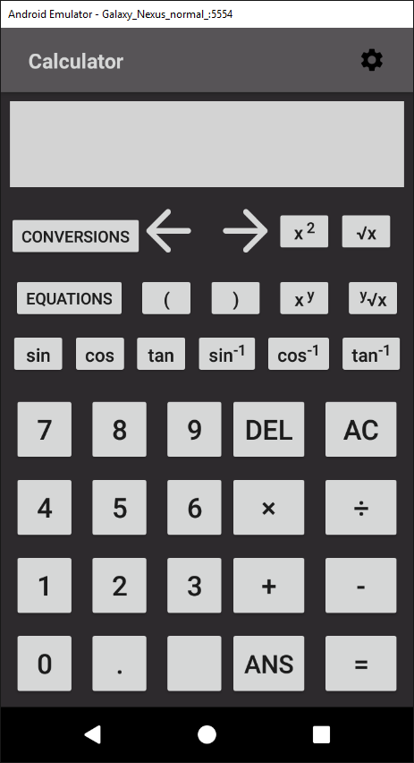

### 5.2.1.2 *calculator.xml (landscape)*

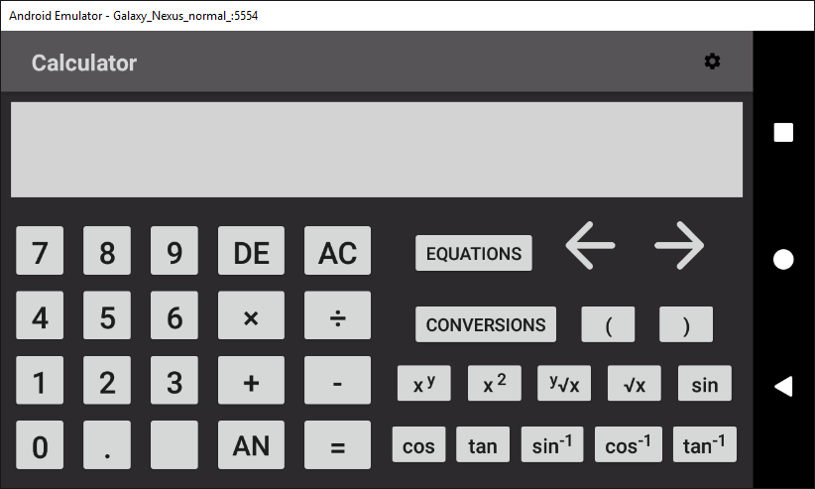

### 5.2.2 *equations.xml*

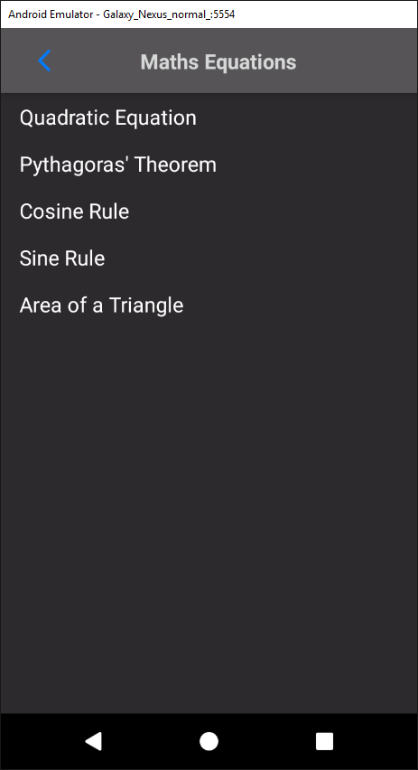

### 5.2.3 quadratic_equation.xml

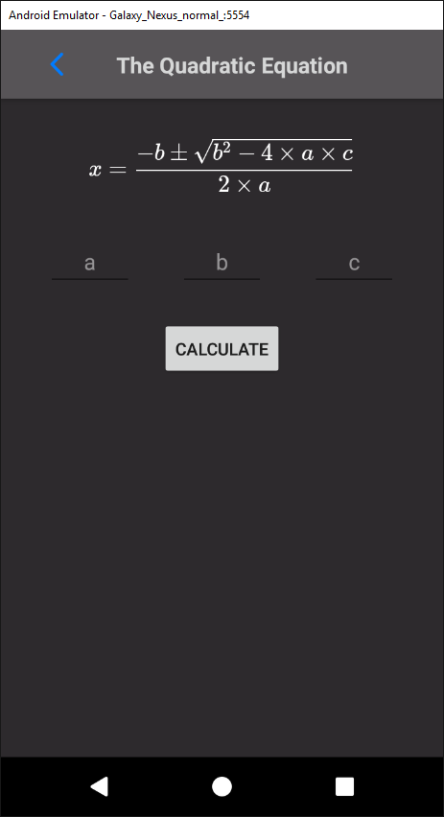

### 5.2.4 pythagoras_theorem.xml

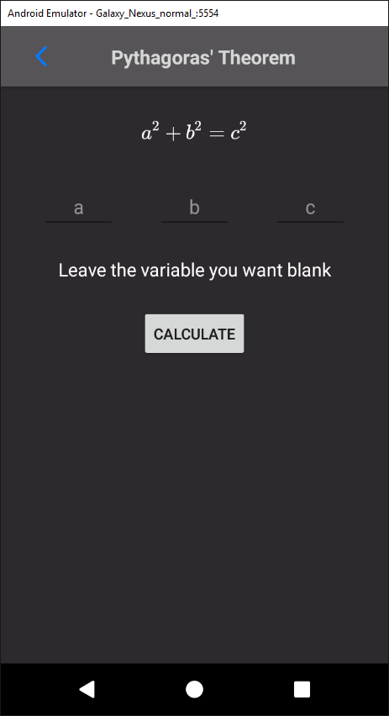

### 5.2.5 *cosine_rule.xml*

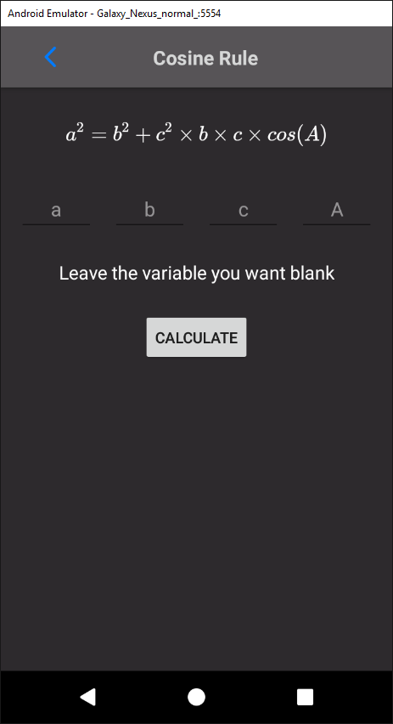

### 5.2.6 sine_rule.xml

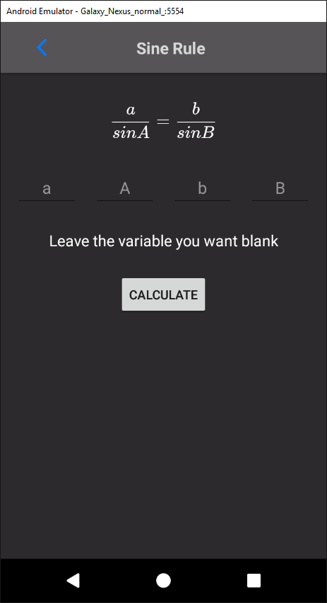

### 5.2.7 area_triangle.xml

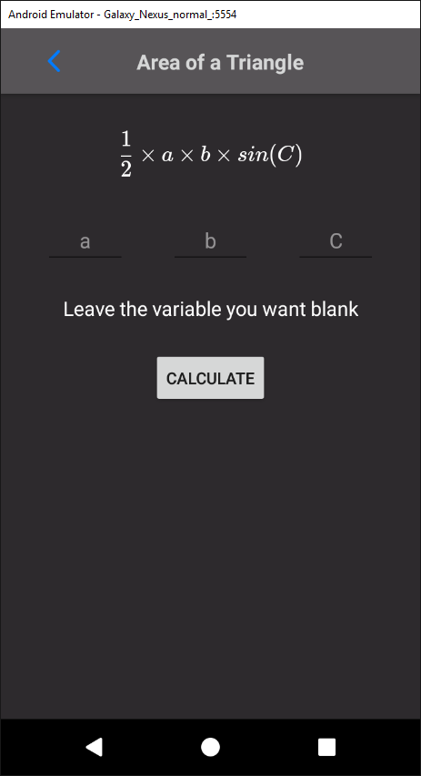

### 5.2.8 *conversions.xml*

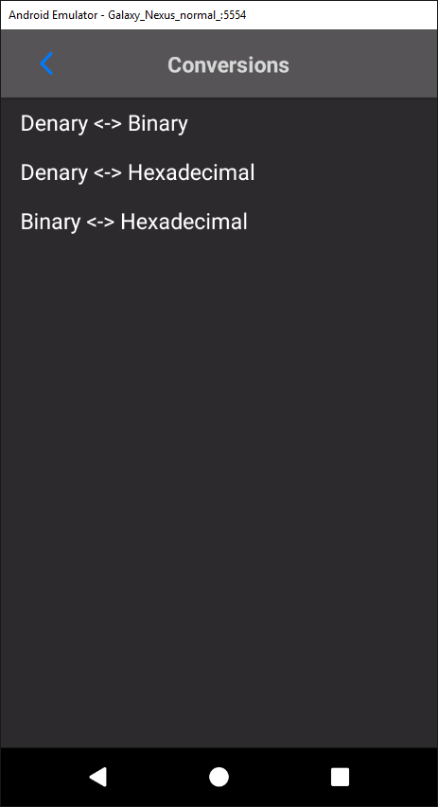

### 5.2.9 conversions_dialog.xml

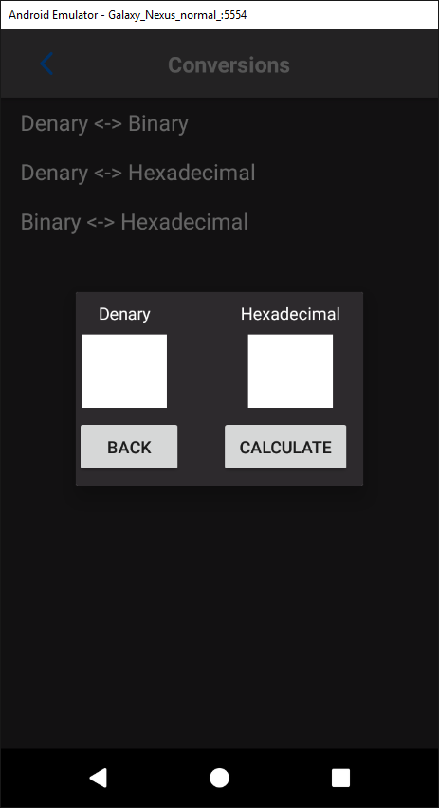

### 5.2.10 settings.xml

